Name of Location:

***Entombed Capitol –*** Stylised as ꍟꈤ꓄ꂦꂵꌃꍟꀸ ꉓꍏꉣꀤ꓄ꂦ꒒ when displayed as the player enters the area for the first time.

World Description:

This location is based on a small island off the coast of the modern-day United Kingdom, where the small kingdom of Frostheim has taken root and grown to encompass the entirety of the island. The kingdom is renowned outside of the island for its potions, with travelers and merchants regularly making their way to the island to take advantage of their prowess. The kingdom is highly similar to the medieval societies of Europe, sharing many of the same practices as those of the English at the time. Due to their reliance on selling their potions to other nations, alchemy has a heavy focus for their people, with the king regularly searching for any potentially s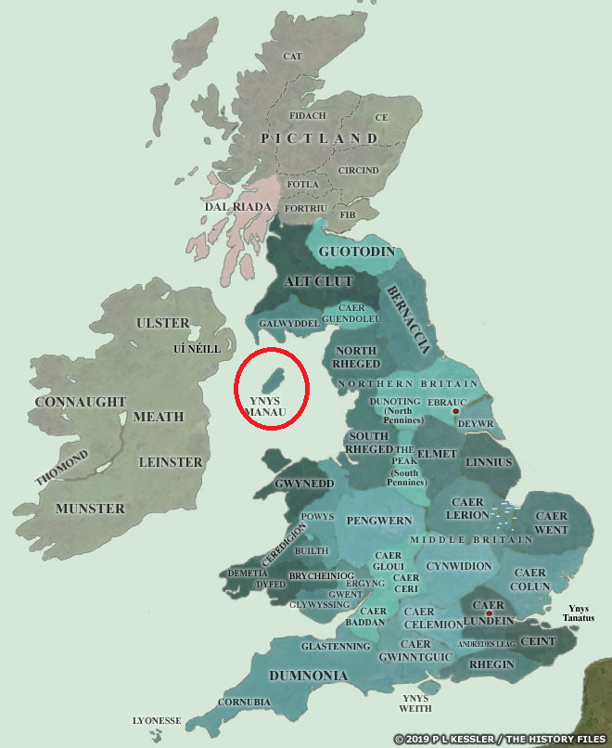killed alchemists to come to the capital and develop new concoctions that can be sold. Recently, however, the island has been seeing less travel as the ocean around them has become extremely dangerous to cross, causing a depression to fall upon its people. To make matters worse, the kingdom guards have been commandeering persons for unknown reasons with citizens failing to return home for months on end, leading their families to consider them missing.

Area History:  
Found at the centre of the island, this dilapidated monolith once acted as the bustling capital of the island nation during its adolescence but after a sudden fire from the castle’s basement erupted, the city became engulfed in the flames and razed to the ground with only a single tower remaining. Since the fall of the city, to dissuade the public from venturing into the ruins of the city, the king sanctioned that a labyrinth be erected around the solemn tower, isolating the tower to only those trusted by the king and his guards. With dark clouds surrounding the ruined obelisk, it became a popular challenge for teenagers and rebellious folks to attempt to enter the maze and claim a souvenir from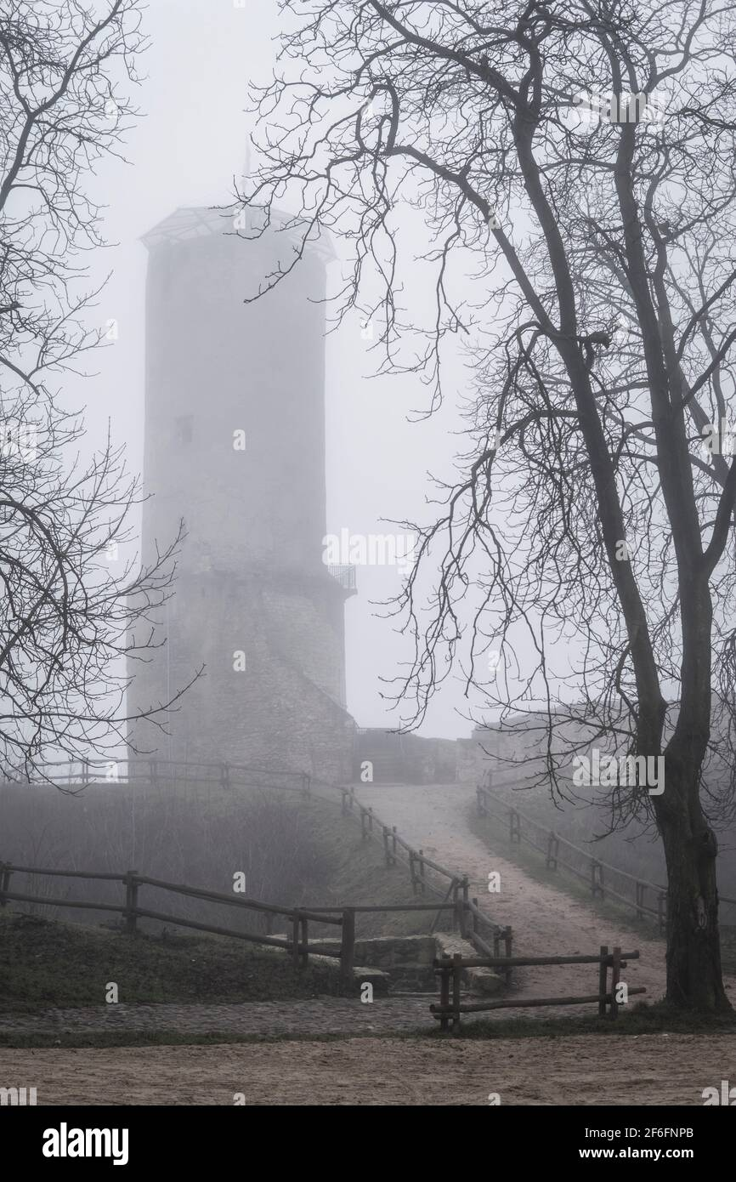 the former town, with guards routinely patrolling the area and punishing all those found attempting this feat. Recently, reports of heavy guard activity from the area of the city, with several individuals claiming to have seen lines of people being escorted into the tower with only guards ever seen leaving. As the king’s open desire for stronger potions and quest for more power grew, nearby residents swore to strange noises and lights emanating from within the depths of the hallowed monument.

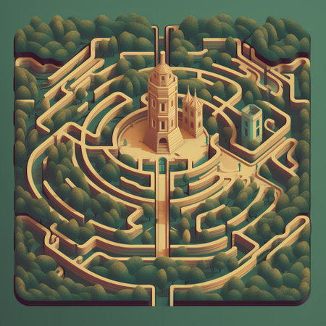

Interactable NPC:

Stationed at the entrance to the Capitol's maze is one of the kingdom’s guards, set there to dissuade curious children or daring adventurers from attempting to enter the dilapidated ruins. This guard is extremely strict and direct with their instructions to anyone who speaks with them, either by attempting to distract them so someone can slip past, or for anyone trying to draw out any information they can about the ruins and why they’re being guarded. Their curt and short-tempered responses express the danger of the area, and their presence alone implies a possible hidden value that the king sees within the mausoleum. The guard will quickly try to shoo the player away and warn of arrest should they be found trying to enter the Capitol before returning to their post.

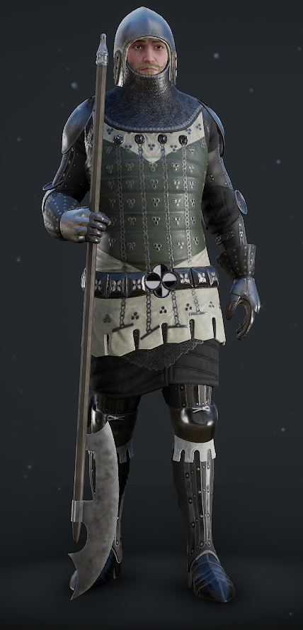

Quest:

With the player acting as an impromptu rogue investigator, the quest associated with this area is to navigate the maze while avoiding any guards patrolling through the area, and sneak into the former capitol building to uncover why all signs show to the missing citizens being transported to the area and never coming back out. The quest culminates with entering the building to discover a secret laboratory buried deep beneath the building’s foundation where the missing citizens are located, locked up, anesthetised, and barely clinging to life. Several other bodies are found within cages and cells, with signs of what appears to be an archaic ritual being performed in the dungeon's large antechamber and a variety of alchemic materials and equipment scattered throughout the rooms.

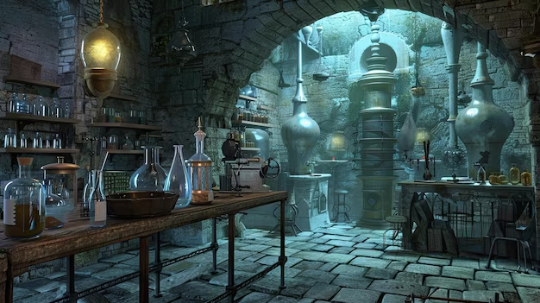

NPC Dialogues:

Dialogues will be handled by utilising the xNode package to develop a node graph system, one per character with dialogue interaction, utilising the node style we previously used in class. Dialogues will be initiated by the player through a raycast interaction with an NPC that has a dialogue graph attached to it, setting active the specific dialogues when called. Players will have a limited number of responses, with a few of the options being used to explain the scenario and loop back around to choose a new response option.

* *Guard Dialogue:*

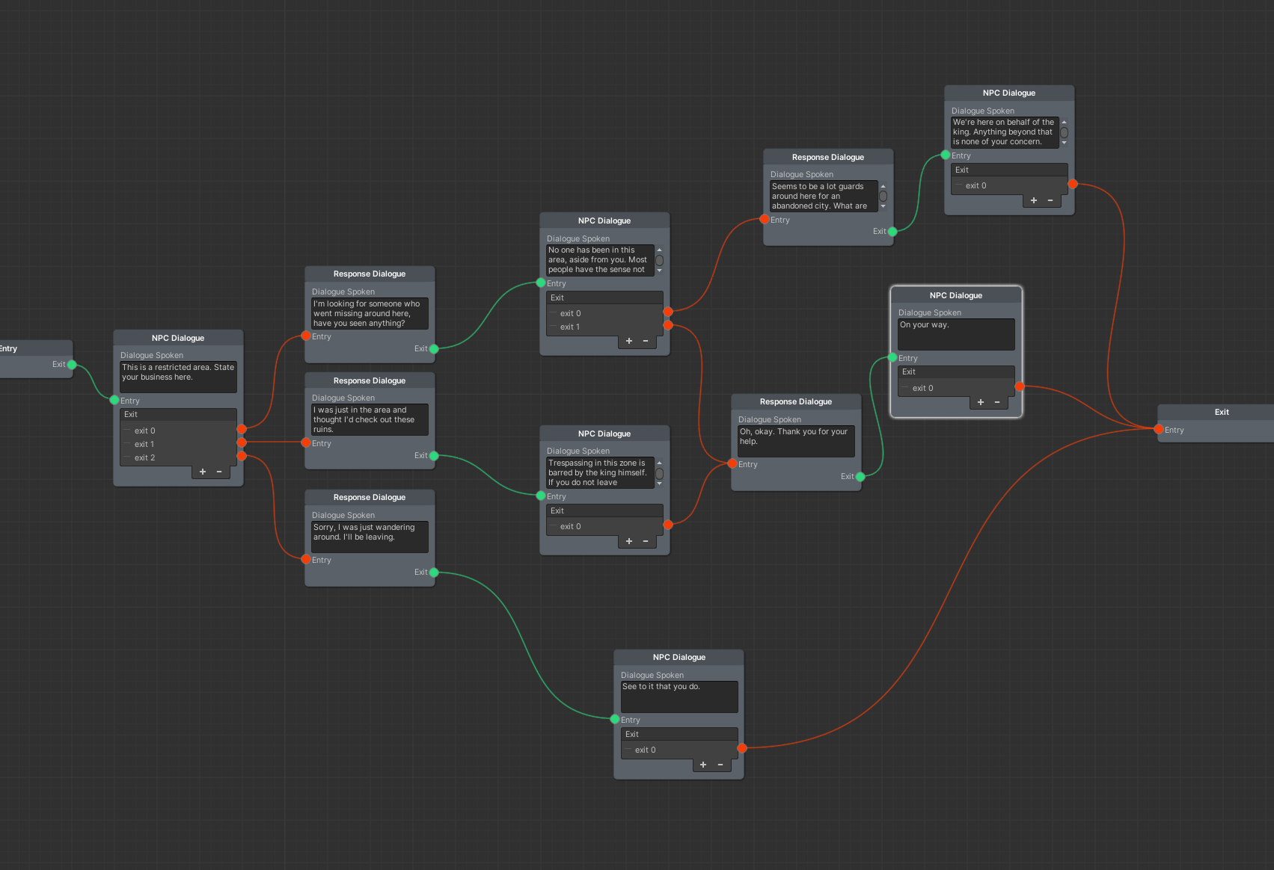

* *Prisoner Dialogue:*

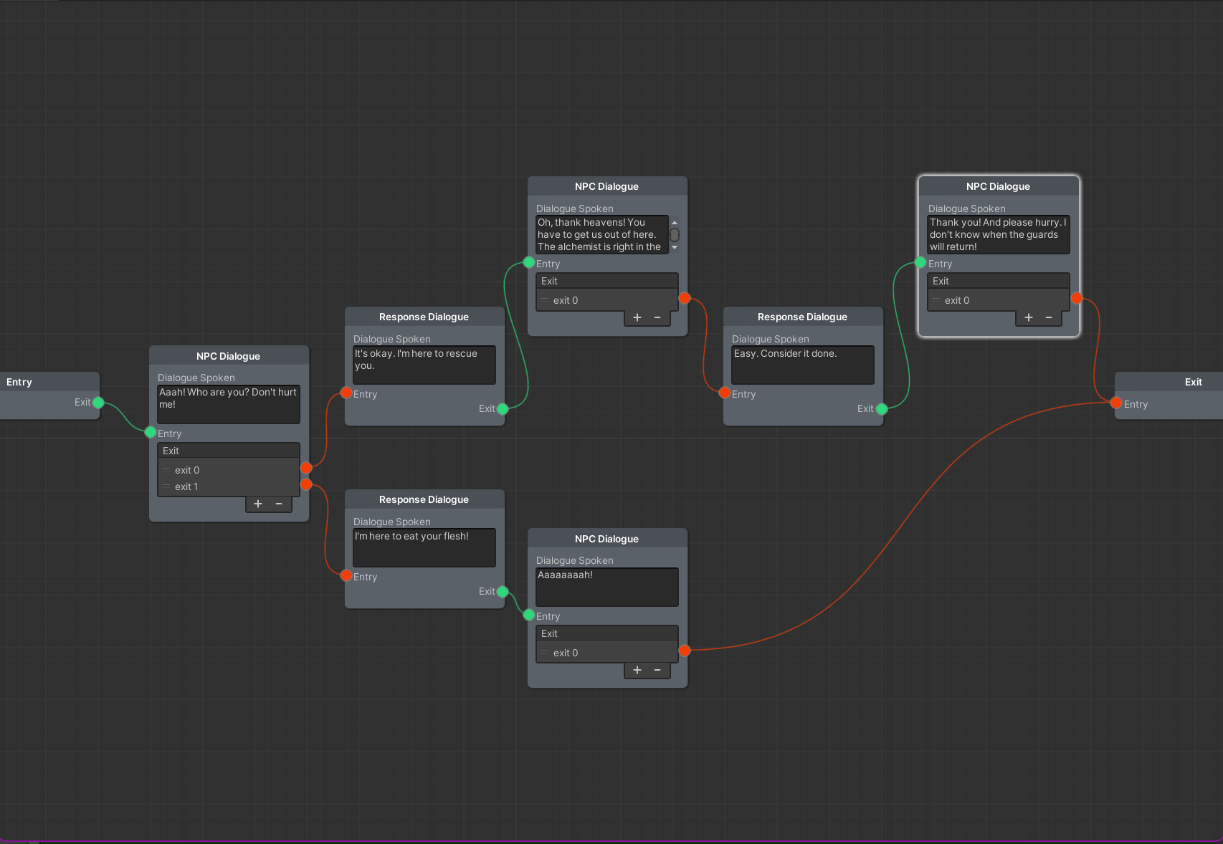

* *Alchemist Dialogue:*

